**ABLE ACCOUNTING SYSTEM**

**User Guide**



# Table of Contents

Table of Contents 2

1. Setting up your Company file 4

1.1 Creating a Company file 4

1.2 Login 7

1.3 Setting up using existing Database 8

1.3.1 Default port 10

3. Advance Setup 11

1.4 Setup Sales 11

1.5 Setup Purchase 12

1.6 User Maintenance 13

1.6.1 Creating new users. 13

1.6.2 Change User Access 14

1.6.3 Changing Password 14

3. Sales 15

1.7 Creating a customer profile 15

1.8 Entering Sales 17

1.9 Receiving Payment 19

1.10 Changing Status of a Sale 21

1.10.1 To change a quote to an order or invoice 21

1.10.2 To change an order to invoice 21

1.11 Printing Payment Receipt 21

2. Purchases 23

2.1 Creating a supplier profile 23

2.2 Entering Purchases 25

2.3 Paying Bills 27

2.4 Changing Status of Purchase 28

2.4.1 To change a **Quote** to an **Order** or **Bill** 28

2.4.2 To change an **Order** to **Bill** 28

3. Banking 28

3.1 Receiving Money 29

3.2 Spending Money 30

3.3 Bank Deposit 32

4. Inventory 32

4.1 Creating Items 32

4.2 Building Items 35

4.2.1 To build item manually 35

4.2.2 To define an auto-build item 36

4.2.3 To auto-build an item 36

5. Transactions 36

5.1 Finding Transactions 36

5.1.1 Using Transaction Lookup 36

5.1.2 Using Sales Register 36

5.1.3 Using Purchase Register 37

5.1.4 Using Item Register 37

5.1.5 Using Bank Register 37

5.2 Changing or Deleting Transaction 37

5.2.1 Changing Transaction 37

5.2.2 Deleting Transaction 37

5.3 Reversing Transaction 38

5.4 Recurring Transaction 38

5.4.1 To create new recurring transaction 38

5.4.2 To use existing transaction as Recurring 38

5.4.3 Recording Recurring transaction 38

6. Reports 38

7. Company Profile Editor 39

# Setting up your Company file

When setting up company file, you record your company basic information to the system, such as company name, contact information.

## C**reating a Company file**

1. Start Able Accounting System

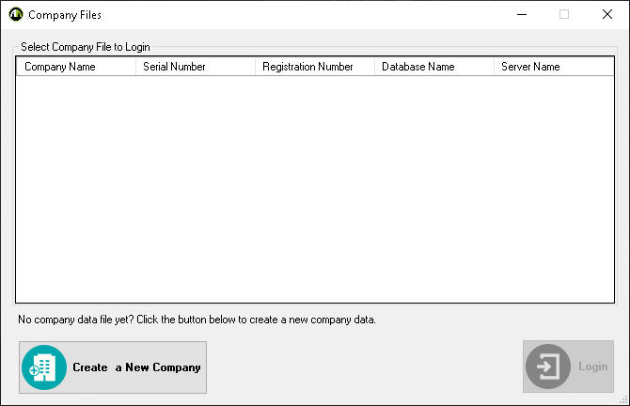

1. Click **Create a New Company.**
2. The Introduction tab of New Company File Assistant will be displayed then click **Next**.
3. The Company Information tab will be displayed. Enter the company’s information then click **Next.**
4. The Accounting Information Tab will be displayed. Enter the Accounting Information then click **Next**.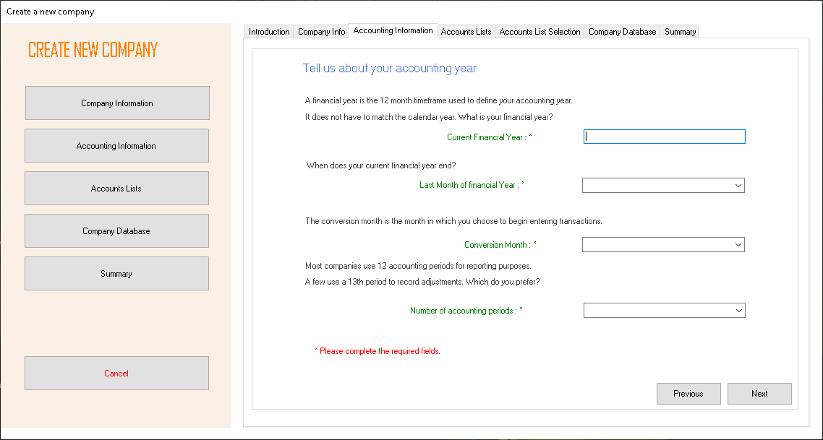
5. The Accounts List tab will be displayed. Select the account list you preferred then click **Next**.

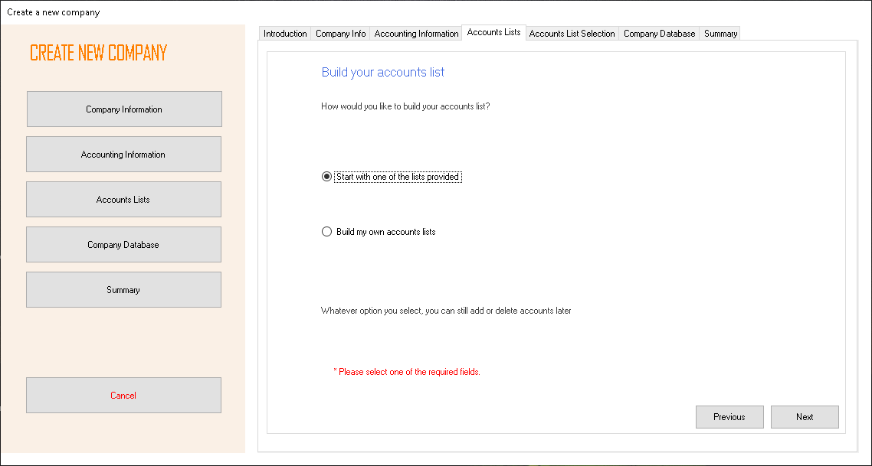

1. The Accounts List Selection will be displayed. Select the Industry Classification and Type of business you are in. 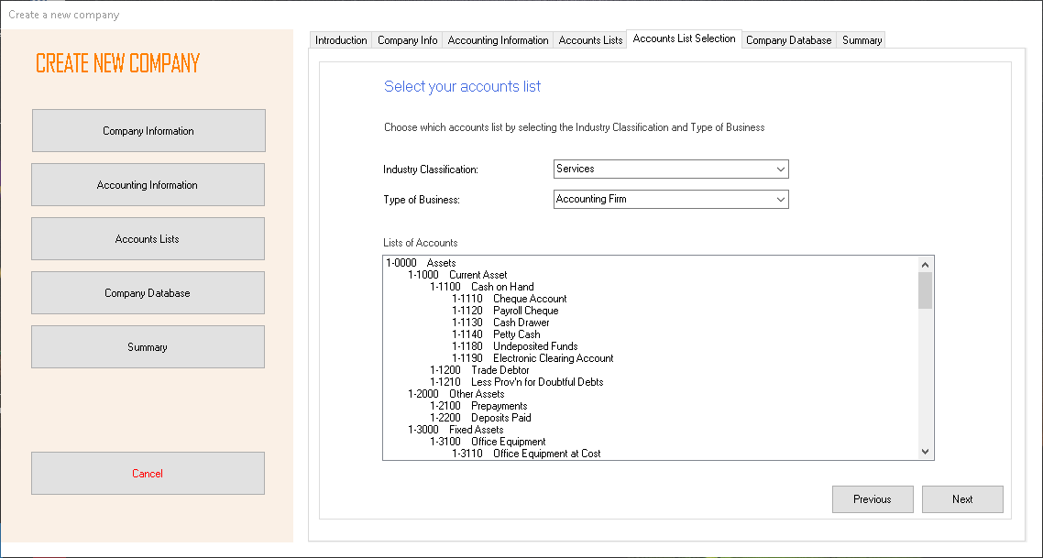
2. The Company Database tab will be displayed. Fill this section about your server and database information then click **Next.** 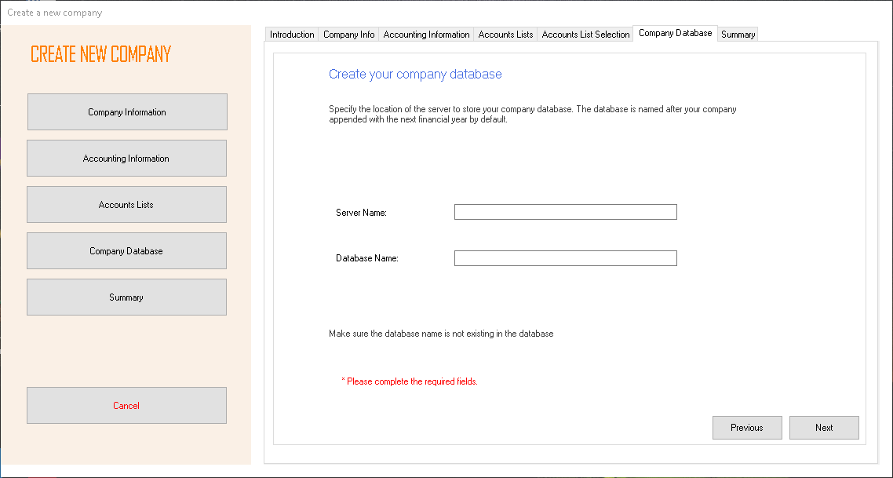
3. Summary tab will be displayed. Review the company information you entered then click **Proceed**.

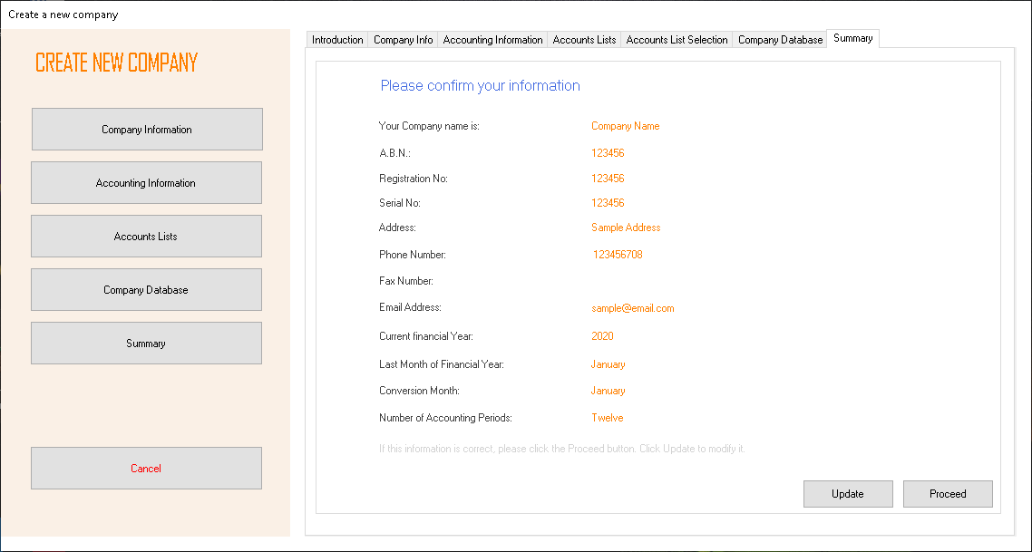

## Login

1. Start Able Accounting System
2. The Company Files will be displayed. Select a company then click **Login** or double click the desired company to login. 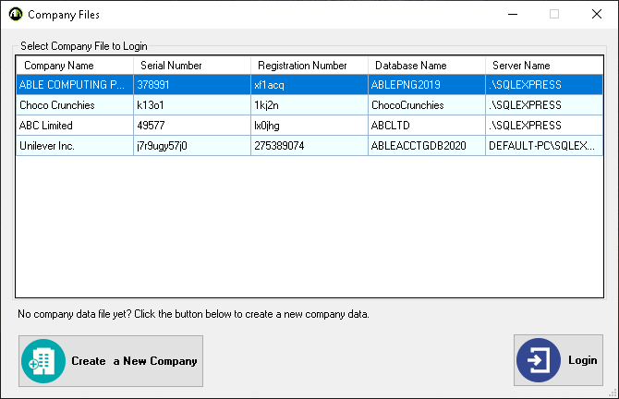
3. Login form will be displayed. Enter the Username and Password then click **Login**. 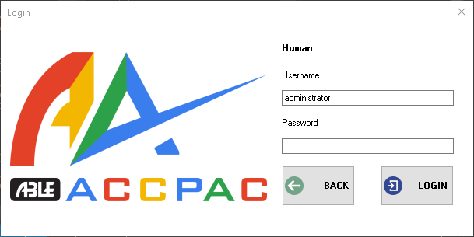
4. The Main page will be displayed. 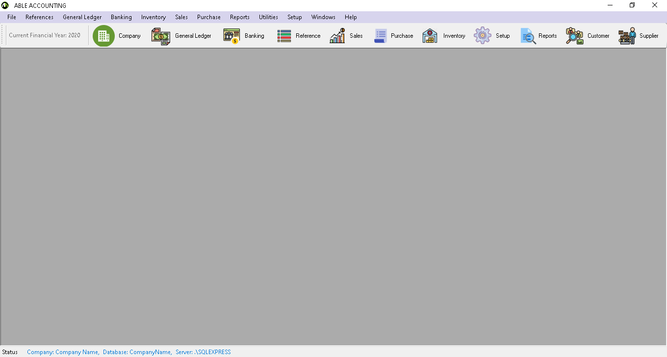

## Setting up using existing Database/Multi User

First setup the SQL Server to be enabled to access using IP address.

1. Go to SQL Server Configuration Manager of your computer by typing **SQL Server Configuration Manager** on your Startor **Windows key + R** to Open the run window then type **compmgmt.msc** then click **OK** or Right click the Windows Start then click **Computer Management** then go to **Services and Applications**.
2. In SQL Server Configuration Manager. Open SQL Server Network Configuration > Protocol for SQLEXPRESS.
3. Double click the **TCP/IP** Protocol.
4. Select **Yes** in the **Enabled** field.
5. switch to the **IP Addresses** tab.
6. Find the **IPAll** section.
7. Clear the TCP Dynamic Ports field and fill the TCP Port with the **Default Port.** To know the Default Port see 1.3.1 Default Port.

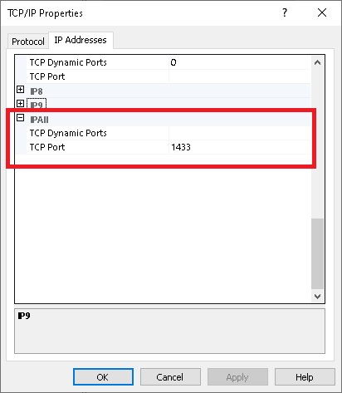

1. Restart SQL Server Service.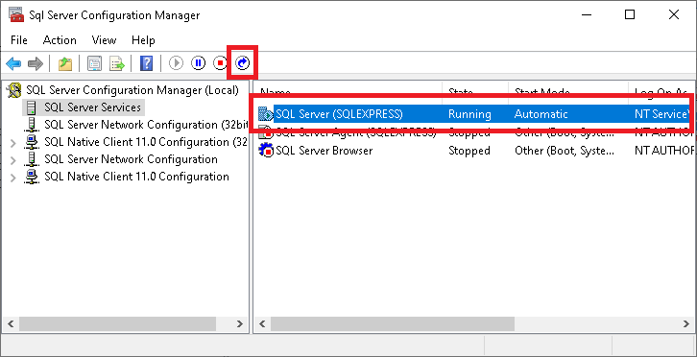
2. Open CoProEditor of the connecting pc then click **Browse.** Select the config.json file where your Able Accounting System is installed.

Note: connecting pc is the computer that wants to connect to the database. 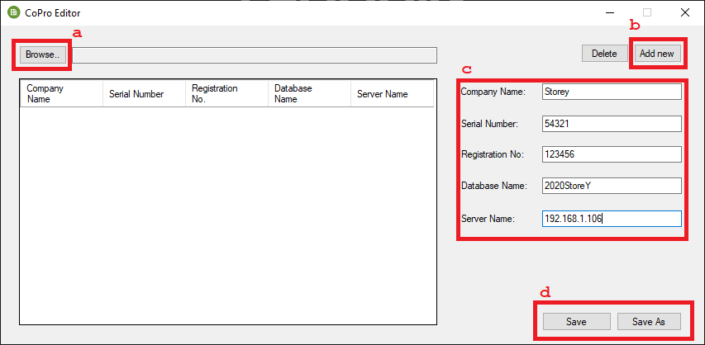

* 1. Click **Browse.**
  2. Click **Add new** to add the company to the connecting pc.
  3. Enter your company details. As Server Name use the IP address of the computer where the server is installed plus default port use comma as separator. Example, 192.128.243.21,1433 .
  4. **Save** or **Save as** and chosethe **config.json** file.

1. Open the Accpac application then login.

### Default port

1. In the SQL Server Configuration Manager. Go to SQL Native Client Configuration > Client Protocols
2. Double click TCP/IP. 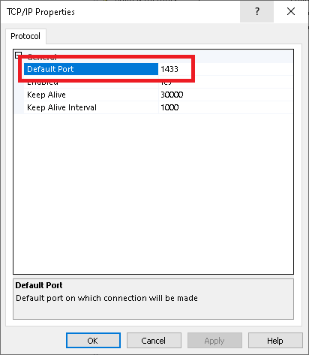

# Advance Setup

After creating a company, to start recording transactions of your company you need to set up Linked accounts.

## Setup Sales

Before you can record sales transactions you need to set linked account to keep track of Receivables and Receipts.

1. After Login. Click on **Setup** then click **Linked Accounts** and click **Sales Linked Accounts.**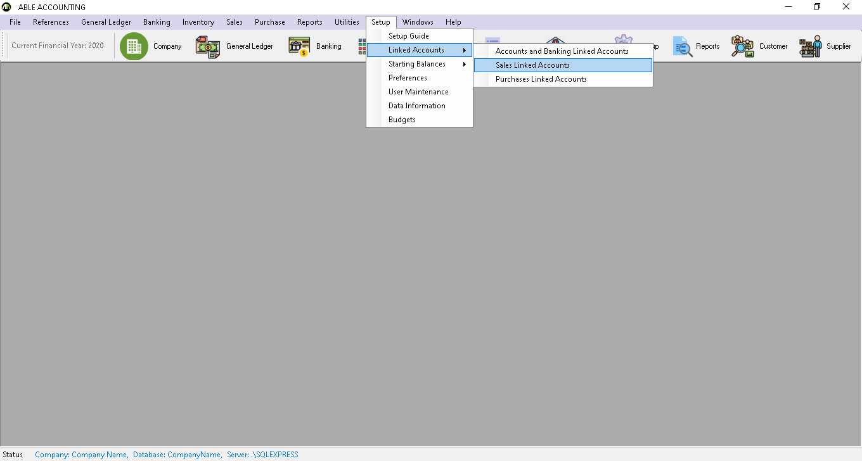
2. **Sales Linked Accounts** formwill be displayed. Click the icons to open Account Lookup to select an account to keep track of your sales transactions.

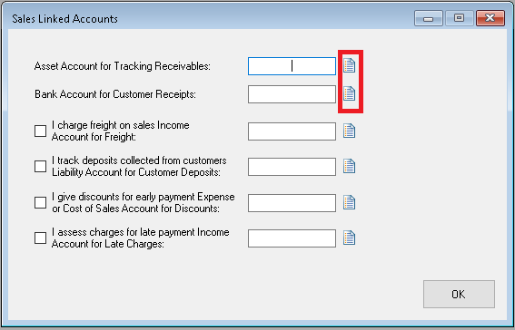

## Setup Purchase

Before you can record purchase transactions you need to set linked account to keep track of Payables and Bills.

1. After Login. Click on Setup then click Linked Accounts and click Purchase Linked Accounts**.**

## User Maintenance

### Creating new users.

1. Go to **Setup** and click **User Maintenance**. 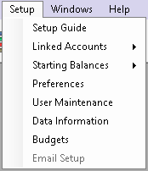
2. The **User Maintenance** form will be displayed.Click **Add User**.
3. Enter the new user, User Name, Password, Full Name and Department, Check the active box and click **Save**.

### Change User Access

1. Go to **Setup** and click **User Maintenance**. 
2. The **User Maintenance** form will be displayed. Go to **User Access** tab.
3. Change the user access by checking and unhecking the box.

### Changing Password

1. Go to **Setup** and click **User Maintenance**. 
2. The **User Maintenance** form will be displayed. Select the user that the password needs to be changed.
3. Changed the password then click **Save**.

# Sales

This chapter show how to record sales transaction to your customers.

## Creating a customer profile

1. Go to **Reference** and click **Customer** or click **Customer** in the tool strip.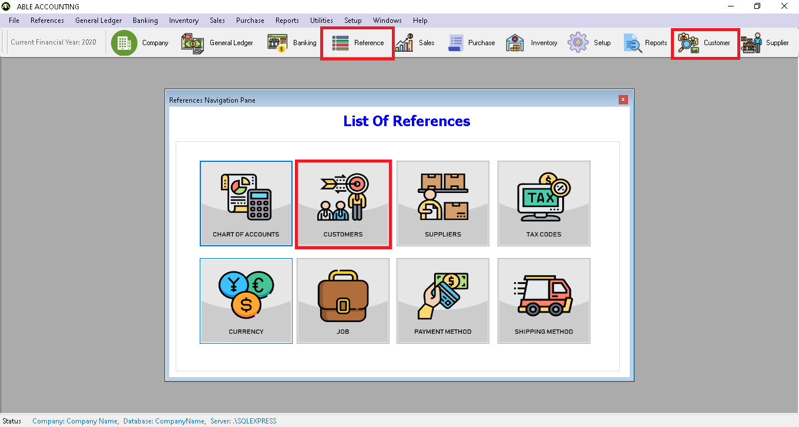
2. The customer list will be displayed. Click **ADD NEW**.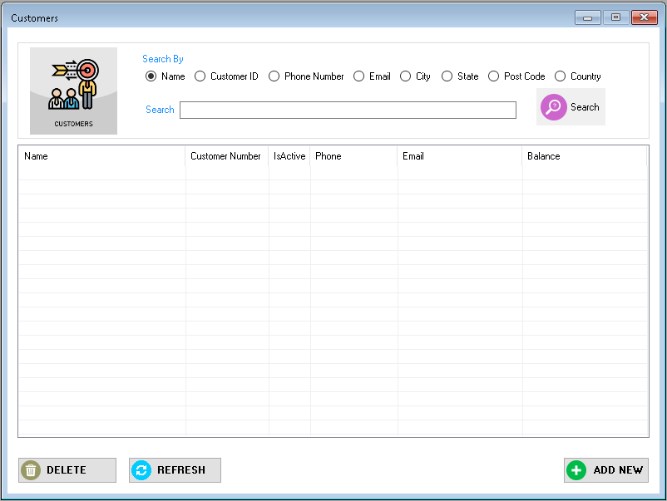
3. The add customer form will be displayed. Enter your customer information. If the company has more contact information. Select Address 2 from the location list and enter the additional contact information. A company can enter five contact information.

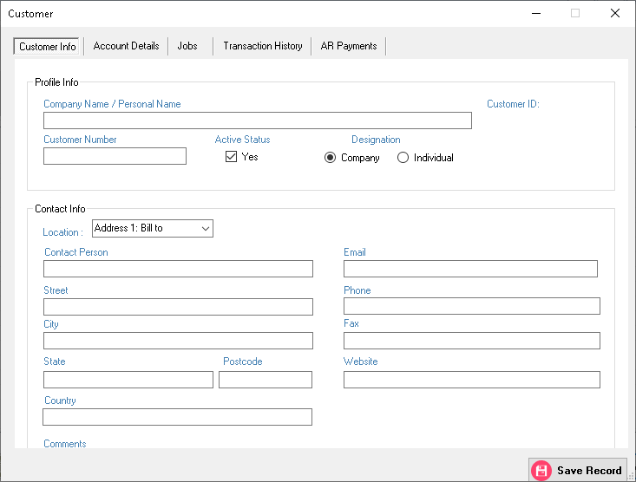

1. Go to Account Details Tab to enter your customer payment method your customer will use to pay you. Fill the necessary details then click **Save Record**.

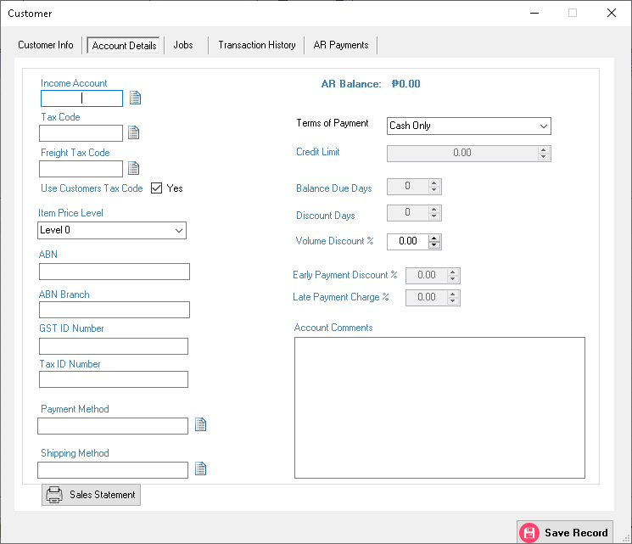

## Entering Sales

1. Click **Sales** in the tool strip to show the Sales Navigation Pane then click **Enter Sales**.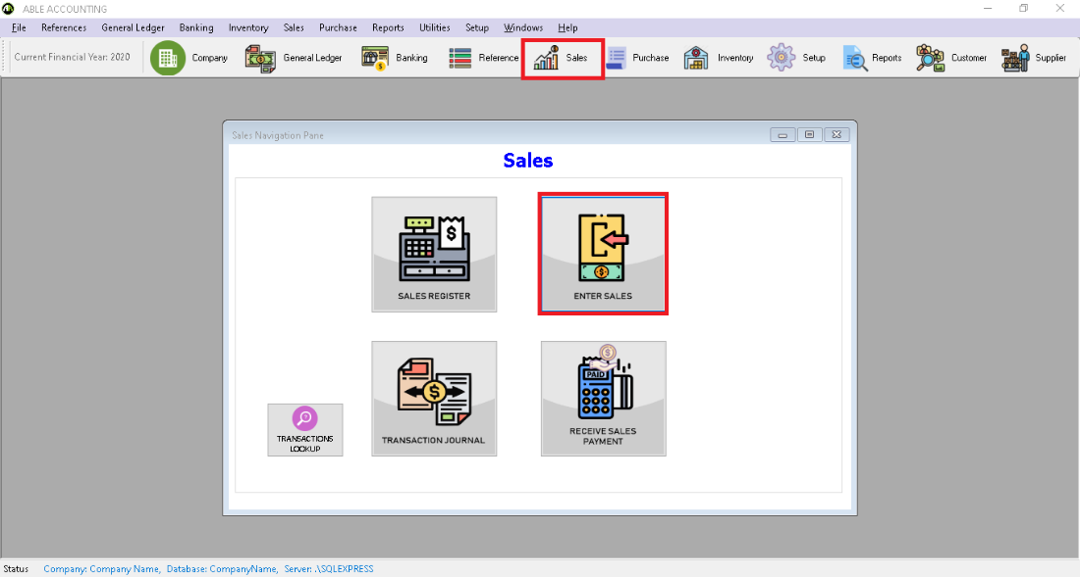
2. The Enter Sales form will be displayed.
3. Enter Sales Details. 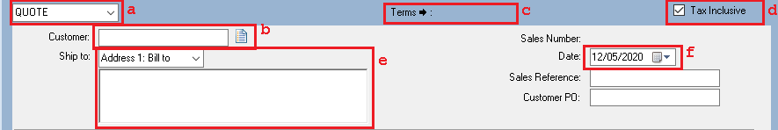
4. Select the type of sales you want to record.
5. Click the icon ( ) in customer field, The customer profile lookup will appear and choose a customer.
6. [Optional] Click to change term for this sale. Default value will be the value entered in customer account details.
7. [Optional] Check is sales include tax.
8. [Optional] Default Ship to address is Address 1.
9. [Optional] Transaction Date change when transaction occurred.
10. Select **Layout** item or service.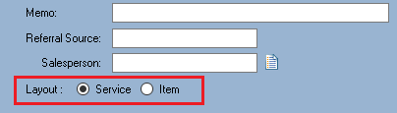
11. Entering transaction lines of the sale. The illustration below shows the field for **Service Layout.**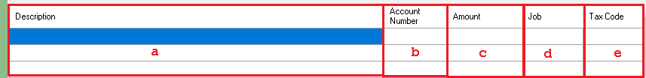
    1. Description of the service being sold.
    2. Type the Account Number or Double click to display the Account Lookup to select the Account Number to allocate the sale.
    3. Enter the amount of the sale transaction.
    4. [Optional] Double click to display the Job Lookup to allocate the specific job.
    5. Select the tax code of the transaction line. Default is the tax code of the Account Number.
12. Entering transaction lines of the sale. The illustration below shows the field for **Item Layout.**

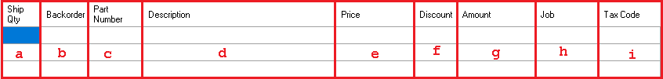

* 1. Quantity of item to be delivered.
  2. Backorder create an order of the item.
  3. Type or Double click to open Item lookup.
  4. Default is the description of the item. Can be change if you want.
  5. Default price is Base Selling Price. Can be change if desired.
  6. Percent of discount if desired to put a discount.
  7. Amount is Auto compute depending on price, Ship Qty., and discount.
  8. [Optional] Double click to display the Job Lookup to allocate the specific job.
  9. Select the tax code of the transaction line. Default is the tax code of the item.

1. Additional information of the sales. 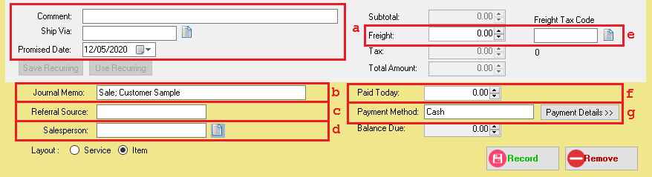
2. [Optional] Comment, Promised Date ,Ship Via click the icon  to display shipping method lookup.
3. Memo is automaticaly generated. Can be change if desired.
4. Referral source is optional.
5. [Optional] Sales person assigned in the sale, click the icon  to open the Sales Person look up.
6. [Optional] Freight amount and Freight Tax Code of the sale.
7. The amount the customer paid at the time of sale.
8. If paid using bank or credit card click the **Payment Detail.** Default Payment Method is the payment method set in the customer Account detail.
9. Click **Record** to save the sales transaction or [Optional] Click **Save Recurring** if the transaction will be regularly recorded**.**

## Receiving Payment

1. Click **Sales** in the tool strip to show the Sales Navigation Pane then click **Receive Sales Payment**.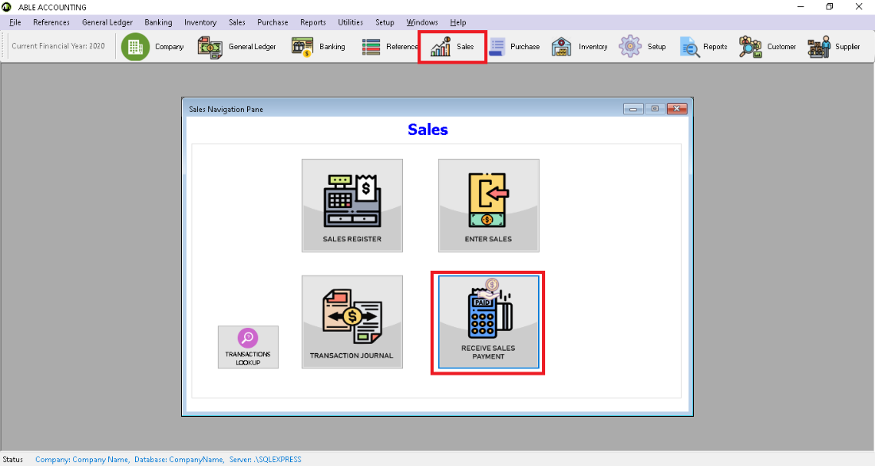
2. **Receive Sales Payment** form will be displayed.

Choose one in the following:

** Deposit to Account**: Type or click the to select the desired bank account.

**Group with Undeposited Funds**: Choose this if you want the deposit to be recorded in undeposited funds account.

1. If the deposited amount is tax inclusive check the **Tax Inclusive**.



1. Enter Payor details.

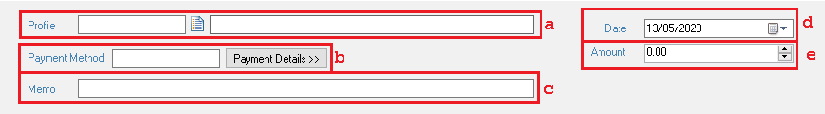

1. ****In the Profile field click to open the Profile Lookup then select the payor.
2. [Optional] Click the **Payment Detail** button to select the method of payment.
3. When selecting a profile automatic Memo will be generated. Can be changed if desired.
4. Change to when is the date of transaction occurred.
5. Amount sent by the receiver.
6. Allocate the amount to the appropriate sale.
7. [Optional] If you want to give a discount.
8. Amount you want to apply in each sale in the column.

Note: Out of Balance must be zero to save the transaction.

1. Click **Record**.

## Changing Status of a Sale

### To change a quote to an order or invoice

1. Go to Sales Navigation Pane and click **Sales Register**.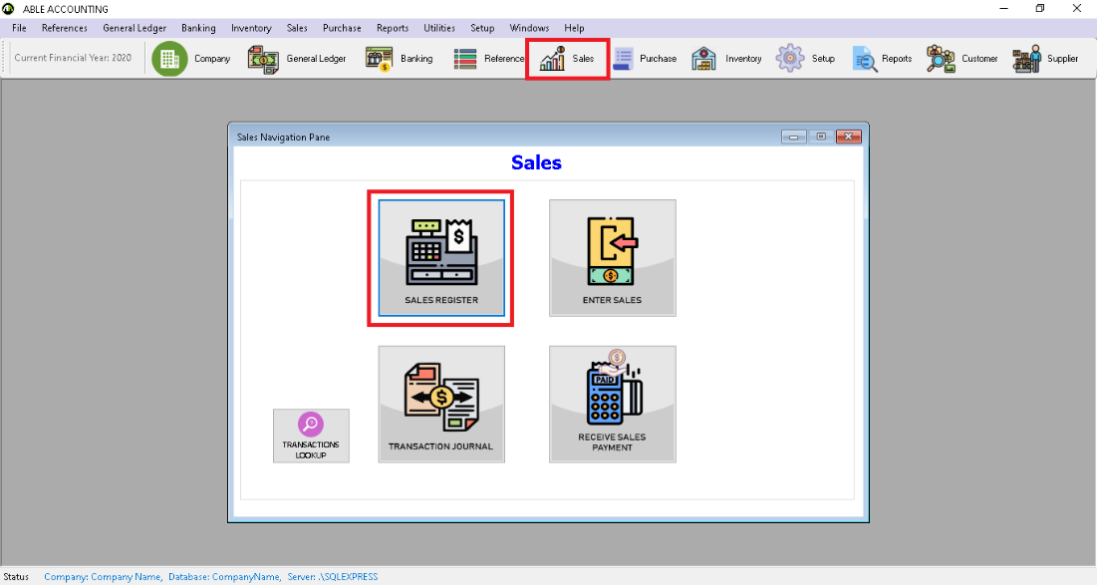
2. Sales Navigation Pane will be displayed. Click the **Quotes** Tab.
3. Change the dates to filter the date of the sale.
4. Select the desired sales record to change and click
   1. **Change to Order** if you want to change it to order.
   2. **Change to Invoice** if you want to change it to invoice.
5. Make necessary change if desired. For example, change the transaction date.
6. Click **Record.**

### To change an order to invoice

1. Go to Sales Navigation Pane and click **Sales Register**.
2. Sales Navigation Pane will be displayed. Click the **Order** tab.
3. Change the dates to filter the date of the sale.
4. Select the desired sales record to change and click **Change to Invoice** if you want to change it to invoice.
5. Make necessary change if desired. For example, change the transaction date.
6. Click **Record.**

## Printing Payment Receipt

Printing receive payment receipt.

1. To Print Payment Receipts.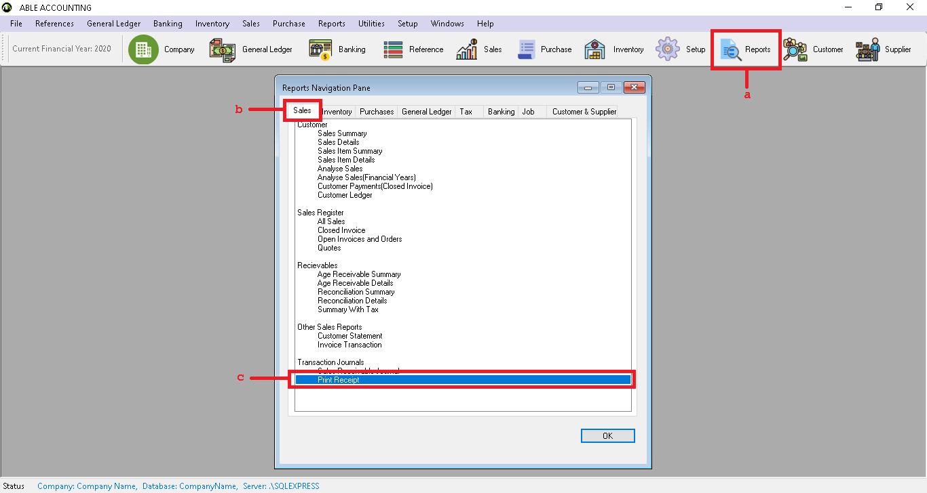
   1. Click **Reports** tool strip.
   2. Click **Sales** tab
   3. Click **Print Receipt** then click **OK.**
2. Print Sales Receipts form will be displayed. Change the dates to filter the transactions.
3. Check the transactions you want to prints then click generate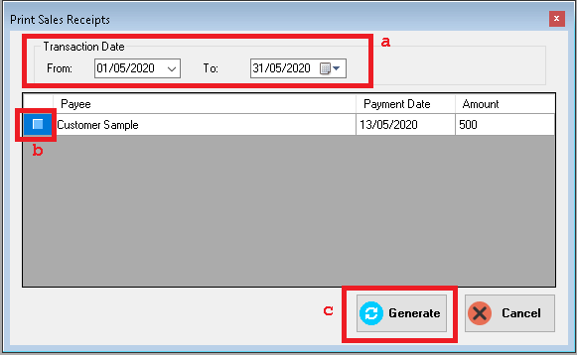

# Purchases

## Creating a supplier profile

1. Go to **Reference** and click **Supplier** or click **Supplier** in the tool strip.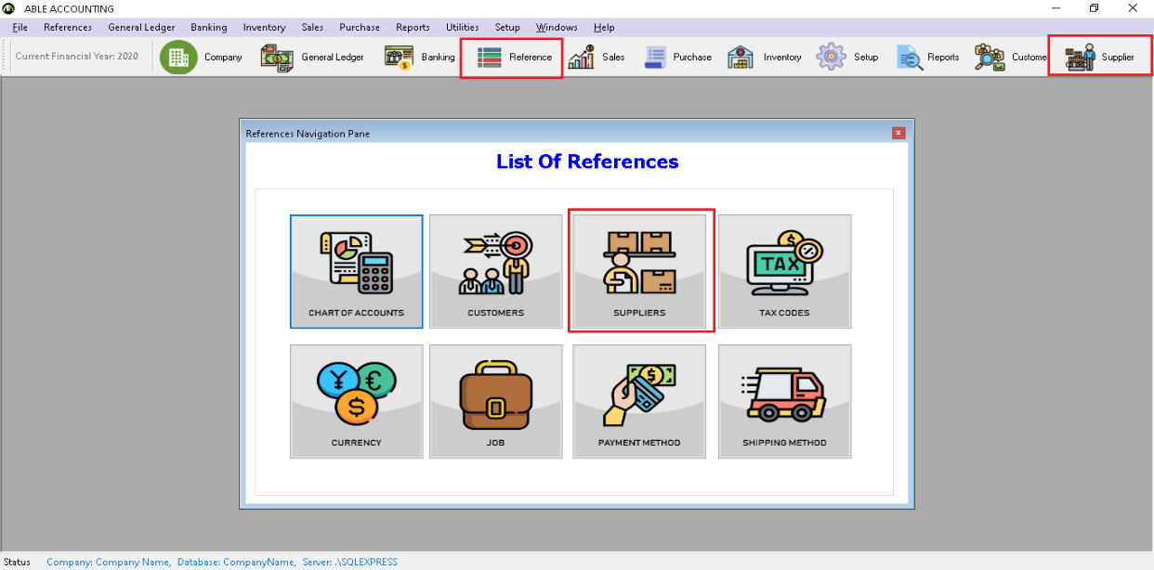
2. The Supplier list will be displayed. Click **ADD NEW**. 
3. The add Supplier form will be displayed. Enter your supplier information. If the company has more contact information. Select Address 2 from the location list and enter the additional contact information. A company can enter five contact information. 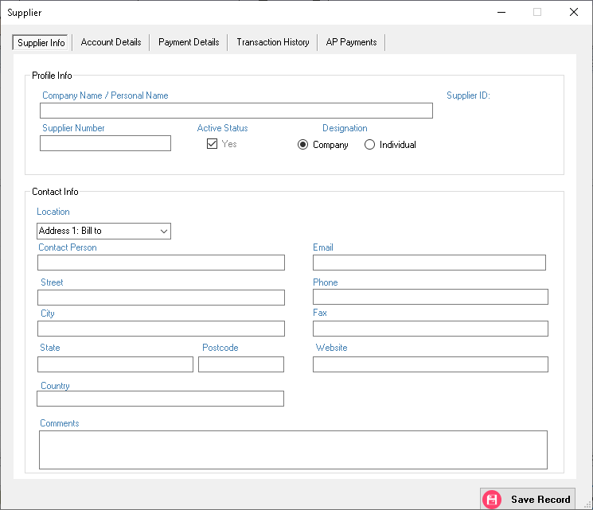
4. Go to Account Details Tab to enter your payment method will use to pay your supplier. Fill the necessary details then click **Save Record**.
5. 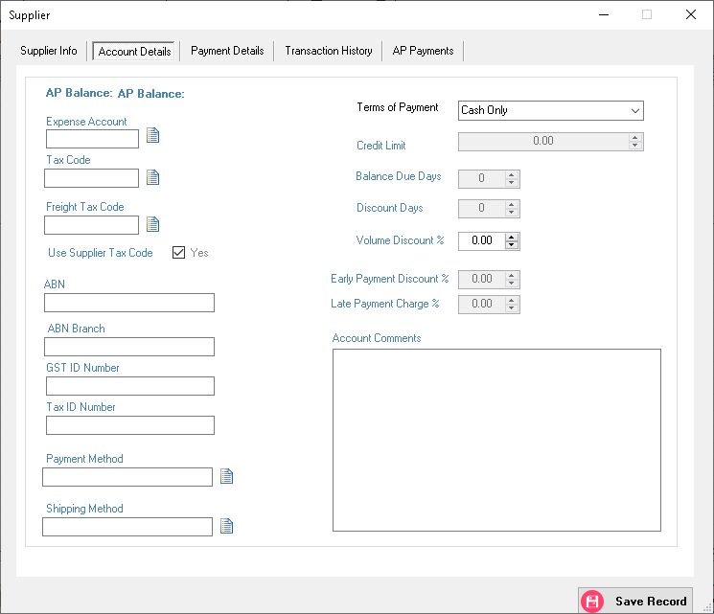

## Entering Purchases

1. Click **Purchases** in the tool strip to show the Sales Navigation Pane then click **Enter Purchases**. 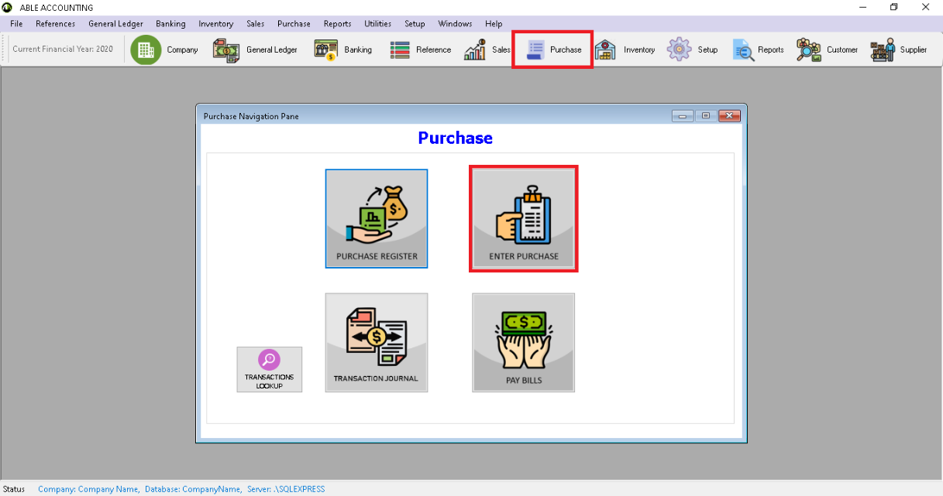
2. Enter Purchases form will be displayed.
3. Enter Sales Details.

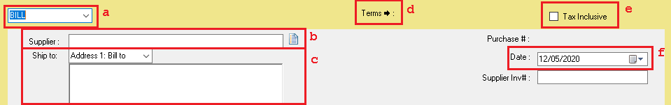

1. Select the type of purchase you want to record.
2. Click the icon in supplier field, the suppler profile lookup will appear and choose a supplier.
3. [Optional] Default Ship to address is Address 1
4. [Optional] Click to change term for this purchase. Default value will be the value entered in supplier account details.
5. [Optional] Check is purchase include tax.
6. [Optional] Transaction Date change when transaction occurred.
7. Select **Layout** item or service

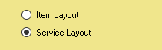

1. Entering transaction lines of the purchase. The illustration below shows the field for **Service Layout.**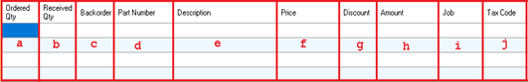
   1. Description of the service bought
   2. Type the Account Number or Double click to display the Account Lookup to select the Account Number to allocate the purchase.
   3. Enter the amount of the purchase transaction.
   4. [Optional] Double click to display the Job Lookup to allocate the specific job.
   5. Select the tax code of the transaction line. Default is the tax code of the Account Number.
   6. Discount Rate given by the supplier.
2. Entering transaction lines of the sale. The illustration below shows the field for **Item Layout.**
   1. Quantity of item ordered from the supplier.
   2. It’s the quantity of item receive against an order.
   3. Backorder create an order of the item.
   4. Type or Double click to open Item lookup. Select the item you need to order.
   5. Default is the description of the item. Can be change if you want.
   6. Default price is Base Selling Price. Can be change if desired.
   7. Percent of discount if desired to put a discount.
   8. Amount is Auto compute depending on price, Ship Qty., and discount.
   9. [Optional] Double click to display the Job Lookup to allocate the specific job.
   10. Select the tax code of the transaction line. Default is the tax code of the item.
3. Click **Record** to save the purchase transaction or [Optional] Click **Save Recurring** if the transaction will be regularly recorded**.**

## Paying Bills

1. Click **Purchases** in the tool strip to show the Sales Navigation Pane then click **Pay Bills**. 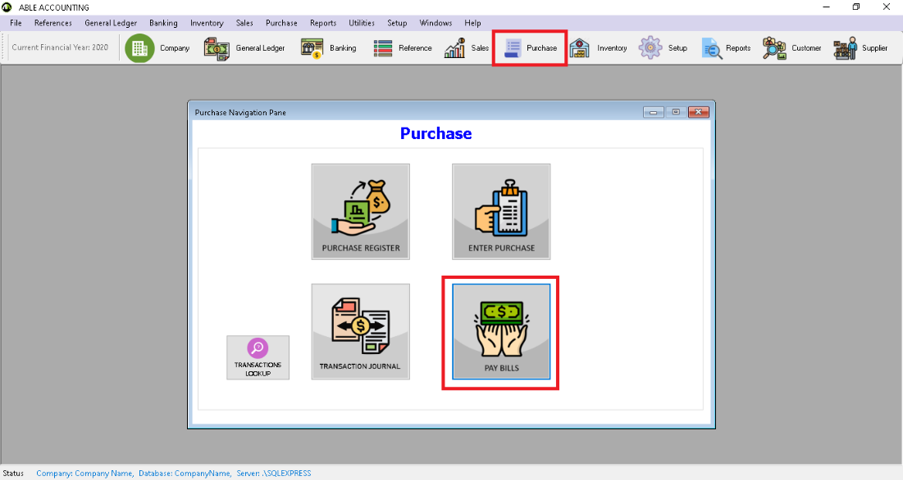
2. **Pay Bills** form will be displayed. Choose one in the following:

**Deposit to Account**: Type or click the icon to select the desired bank account.

**Group with Electronic Payments**: Choose this if you want the deposit to be recorded in Electronic payments account.

1. If the deposited amount is tax inclusive check the **Tax Inclusive**. 
2. Enter Supplier details.

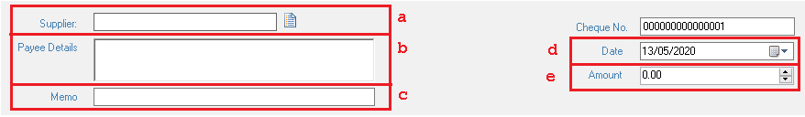

1. ****In the Supplier field click to open the Profile Lookup then select the Receiver.
2. Address of supplier to be paid.
3. When selecting a profile automatic Memo will be generated. Can be changed if desired.
4. Change to when is the date of transaction occurred.
5. Amount paying to the supplier.
6. Allocate the amount to the appropriate account.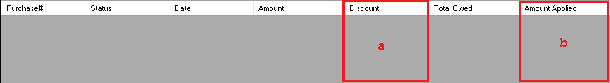
7. If the supplier has given you a discount.
8. How much the payment you want to apply to each purchase in the column.

Note: Out of Balance must be zero to save the transaction.

1. Click **Record** to save the Paying bills transaction.

## Changing Status of Purchase

### To change a **Quote** to an **Order** or **Bill**

1. Go to **Purchase Register.**
2. Click the **Quotes** tab.
3. Select the purchase you want to change.
   1. **Change to Order** if you want to change it to order.
   2. **Change to Bill** if you want to change it to invoice.
4. Enter Purchase form will appear. Make necessary change if desired. For example, change the transaction date.
5. Click **Record.**

### To change an **Order** to **Bill**

1. Go to **Purchase Register.**
2. Click the **Order** tab.
3. Select the purchase you want to change.
4. Click **Change to Bill** if you want to change it to invoice.
5. Enter Purchase form will appear. Make necessary change if desired. For example, change the transaction date.
6. Click **Record.**

# Banking

Record the cheques you have written, the cheques and credit card payments you have received, credit card purchases, withdrawals and deposits.

## Receiving Money

1. Click the **Banking** button in the tool strip, the Banking Navigation pane will be displayed and click **Money In**.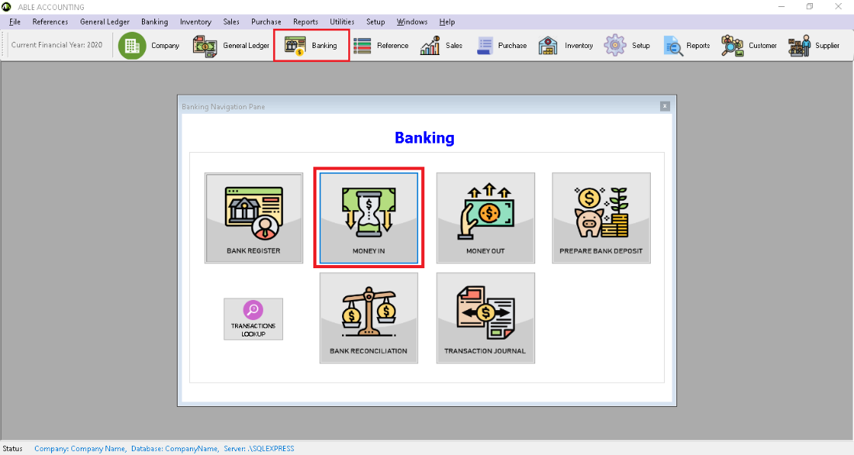
2. **Money In** form will be displayed. Choose one in the following:

**Deposit to Account**: Type or click the to select the desired bank account.

**Group with Undeposited Funds**: Choose this if you want the deposit to be recorded in undeposited funds account.

1. If the deposited amount is tax inclusive check the **Tax Inclusive**.



1. Enter profile details.



1. ****In the Profile field click to open the Profile Lookup then select the Sender.
2. [Optional] Click the **Payment Detail** button to select the method of payment.
3. When selecting a profile automatic Memo will be generated. Can be changed if desired.
4. Change to when is the date of transaction occurred.
5. Amount receive from the sender.
6. Allocate the amount to the appropriate account.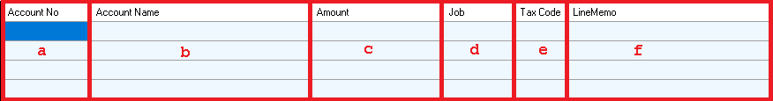
7. Type or double click to select the account you wish to allocate the transaction.
8. Auto fill after account have chosen.
9. Type the amount assign to account.
10. [Optional] Double click to display job lookup and select the job assign to the transaction.
11. [Optional] Default is the tax assign in the account. Double click to show the Tax lookup to change the tax.
12. [Optional] Memo for each transaction.
13. If the Money IN covers more than one transaction repeat step 5.
14. Click **Record** to save the money in transaction or [Optional] Click **Save Recurring** if the transaction will be regularly recorded**.**

## Spending Money

1. Click the **Banking** button in the tool strip, the **Banking Navigation Pane** will be displayed and click **Money Out**.
2. **Money Out** form will be displayed. Choose one in the following:

**Deposit to Account**: Type or click the to select the desired bank account.

**Group with Electronic Payments**: Choose this if you want the deposit to be recorded in Electronic payments account.

1. If the deposited amount is tax inclusive check the **Tax Inclusive**.



1. Enter profile details.



* 1. ****In the Profile field click to open the Profile Lookup then select the Receiver.
  2. [Optional] Click the **Payment Detail** button to select the method of payment.
  3. When selecting a profile automatic Memo will be generated. Can be changed if desired.
  4. Change to when is the date of transaction occurred.
  5. Amount sent to the receiver.

1. Allocate the amount to the appropriate account.
2. Type or double click to select the account you wish to allocate the transaction.
3. Auto fill after account have chosen.
4. Type the amount assign to account.
5. [Optional] Double click to display job lookup and select the job assign to the transaction.
6. [Optional] Default is the tax assign in the account. Double click to show the Tax lookup to change the tax.
7. [Optional] Memo for each transaction.
8. If the Money Out covers more than one transaction repeat step 5.
9. Click **Record** to save the money in transaction or [Optional] Click **Save Recurring** if the transaction will be regularly recorded**.**

## Bank Deposit

1. Click **Banking** in the tool strip to show the Sales Navigation Pane then click **Prepare Bank Deposits**. 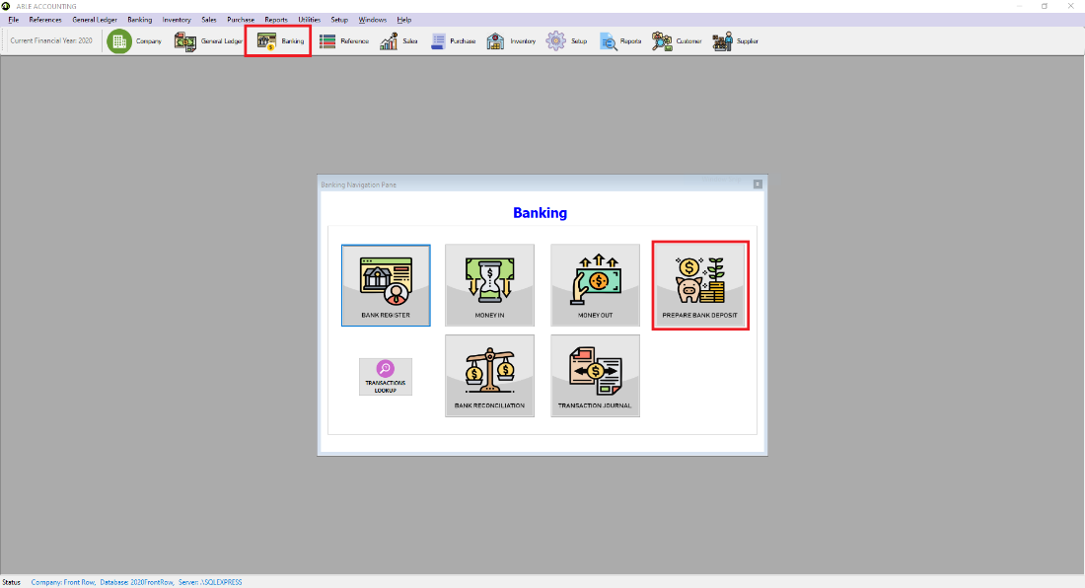
2. An **Account Lookup** form will be displayed. Select the bank account you want to deposit to.
3.  [Optional] To change the bank account click in the Deposit to Account field.
4. By default, all payment method used by the account is set. To select a specific **Payment Method,** uncheck the box and select a specific payment method then click **Show Transactions.**
5. [Optional] Type a description of the bank deposit in the **Memo** field.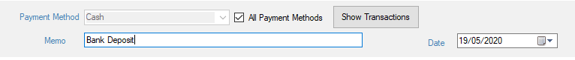
6. Transaction Details will be displayed. Check the **To Be Deposited** column of the transaction you want to record.

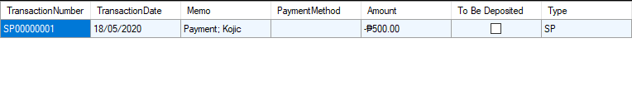Click **Record** to save the Deposit to bank account transaction.

# Inventory

Enable you to keep track of the quantity and values of your item.

## Creating Items

Before you can track your inventory, you need to create a record for each item of your inventory.

**To create an item**

1. Click **Inventory** and click **Items** to open **Item List** form**.**

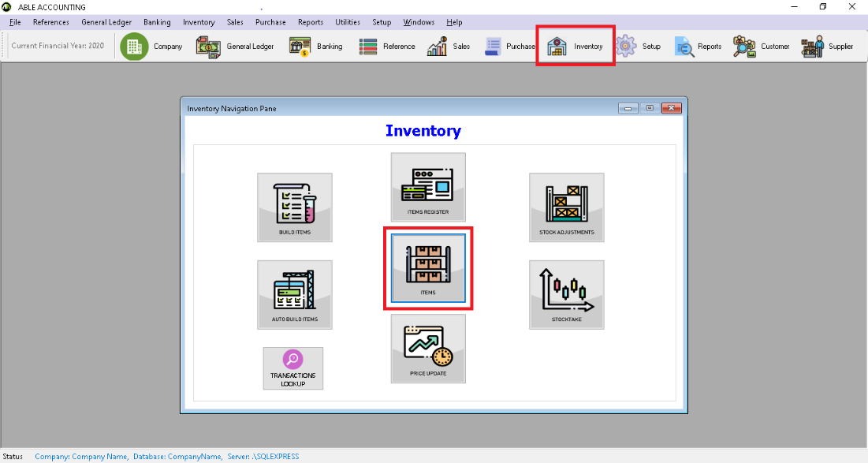

1. Click **Add New.**
2. The Item form will be displayed. Enter the item information.

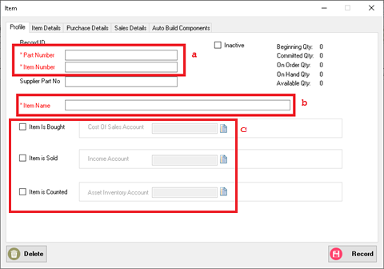

* 1. Enter a unique identifier for the item.
  2. Name of the item.
  3. [Required] Check the box to select which account to associate the item to keep track when the item is bought, sold and in the asset account.

1. Go to **Item Details** tab to enter the item description.
2. Go to **Purchase** **Details** tab to enter the detail when buying the item.

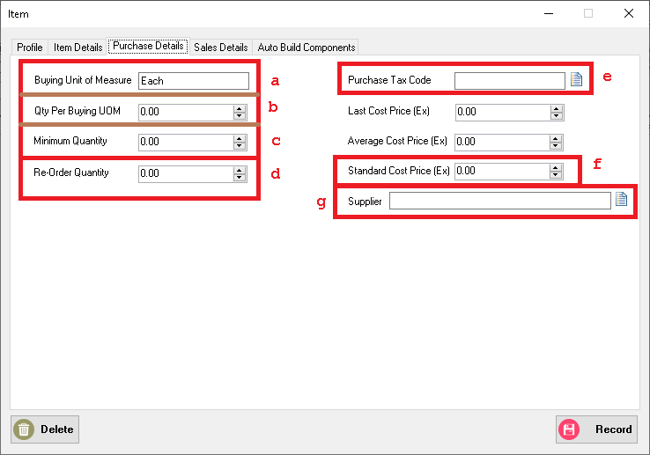

* 1. Type the unit of measure in which you purchase the item.
  3. [Optional]The minimum quantity of item you want to keep in your inventory. When the item drop below this level, a reorder reminder will appear in **To Do List.**
  4. A Reorder quantity of the item.
  6. The Standard cost of the item.
  7. The supplier you order the item.

1. Go to **Selling** **Details** tab to enter the detail when selling the item.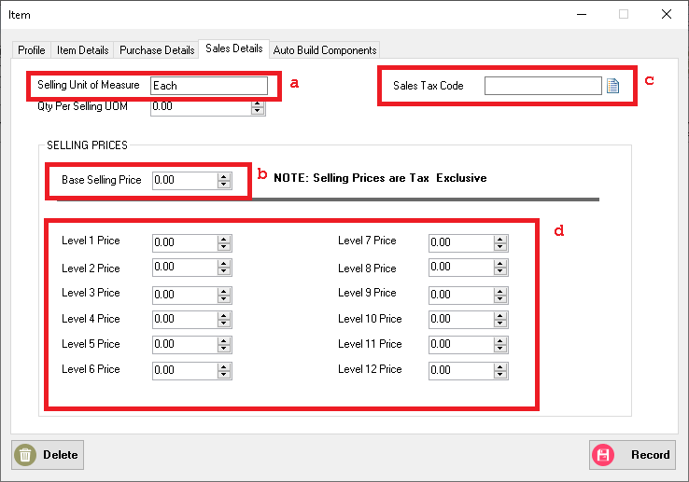
   1. Unit of measure when reselling the item.
   2. Price of the item when reselling.
   3. Set the tax code to use when reselling the item. Can be change in the invoice.
   4. Enter the different pricing level for different customers.
2. Click **Record.**

## Building Items

Building items is the process of combining two or more items to make up another item.

### To build item manually

1. Go to **Inventory Navigation Pane** and click **Build Items.**
2. The **Build Item** form will be displayed. Type or Select the part numbers you want to make and the component items you want to transfer.
3. Type the transfer quantity.
   1. Type the positive number for the finished item (This number is added to your on-hand inventory).
   2. Type the negative number for the component items (This number is subtracted to your on-hand inventory).

Note: Out of Balance field must be zero before you can record the transaction.

1. Click **Record** to save inventory transfer.

### To define an auto-build item

Auto-build items are items that you frequently build. Before you can build the finished item, you need to define the items that you need.

1. Go to **Inventory Navigation Pane** and click **Items**. The **Item List** form will be displayed.
2. Double click the item and go to **Auto-Build Components** tab.
3. Check the This is an Auto-Build Item.
4. Click **Add Part**. An Item List will be displayed select the item you want to add in the auto build item. 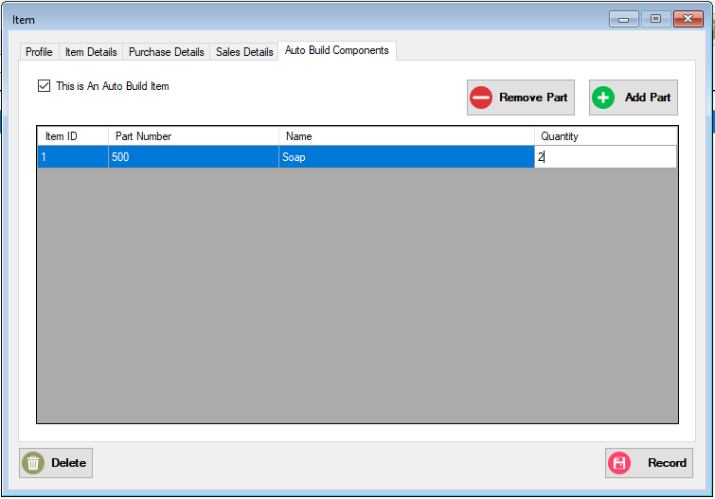
5. Change the quantity of the item then click **Record**.

### To auto-build an item

1. Go to **Inventory Navigation Pane** and click **Auto Build Item**. The **Auto Build Item** form will be displayed.

# Transactions

## Finding Transactions

### Using Transaction Lookup

### Using Sales Register

* 1. Go to **Sales Navigation Pane** and click **Sales Register**. The Sales Register will be displayed.
  2. Filter your search using the **Search by** function. For example, you can change the drop down box to search for a specific customer, adjust the date range for more specific result. You can view the transaction detail by double clicking the selected transaction.

### Using Purchase Register

1. Go to **Purchase Navigation Pane** and click **Purchase Register**. The Purchase Register will be displayed.
2. Filter your search using the **Search by** function. For example, you can change the drop down box to search for a specific supplier, adjust the date range for more specific result. You can view the transaction detail by double clicking the selected transaction.

### Using Item Register

1. Go to **Inventory Navigation Pane** and click **Item Register**. The Purchase Register will be displayed.
2. Filter your search using the **Search by** function. For example, you can change the drop down box to search for a specific item, adjust the date range for more specific result. You can view the transaction detail by double clicking the selected transaction.

### Using Bank Register

* 1. Go to **Banking Navigation Pane** and click **Bank Register.** The Bank Register form will be displayed.
  2. Select the bank, credit card petty cash account you use for the transaction, adjust the date range for more specific transaction. The click Show Transactions.
  3. Select the transaction then click **Check Details** or double click the transaction.

## Changing or Deleting Transaction

### Changing Transaction

Only **Order** transactions can be deleted.

1. Go to Sales Register and go to **Order** tab.
2. Search for the transaction to be edited using the filters.
3. Double click the transaction to be edited.
4. Edit the details you want to change and click **Update.**

### Deleting Transaction

Only **Quote** transactions can be deleted.

1. Go to Sales Register and go to **Quotes** tab.
2. Search for the transaction to be deleted using the filters.
3. Select the transaction and click **Delete**.

## Reversing Transaction

Only **Invoice** transactions can be deleted.

1. Go to Sales Register and go to **Invoice** tab.
2. Search for the transaction to be edited using the filters.
3. Double click the transaction to be edited.
4. Edit the details you want to change and click **Reverse.**

## Recurring Transaction

Recurring transactions are transaction you record regularly.

### To create new recurring transaction

1. Enter Transaction Detail in a Transaction window. For example, Sales Transaction.
2. Click **Save Recurring.**
3. Edit Recurring Schedule, Such as Frequency of transaction, Notification schedule.
4. Click **Save.**

### To use existing transaction as Recurring

1. Find the transaction and load the transaction. see 7.1 Finding Transaction.
2. Click **Save Recurring.**
3. Edit Recurring Schedule, Such as Frequency of transaction, Notification schedule.
4. Click **Save.**

### Recording Recurring transaction

1. Go to **To Do List** in **Utilities**.
2. Select the appropriate Recurring tab.

# Reports

To display and print report.

1. Click the **Reports** tool strip. 
2. The **Report Navigation Pane** will be displayed. Search for the report of the desired print then click **OK**.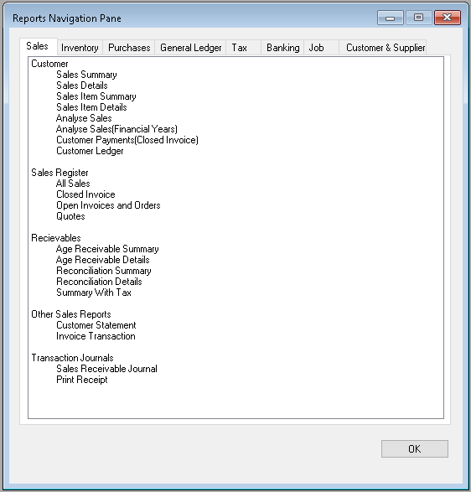
3. A Report Customizer will be displayed. Filter the data you want to be displayed, For example, transaction date, sales status. Then click **Generate**.

# Backup Database

To save your existing database and to restore database for future purposes.

1. Click the utilities under the main tool strip.

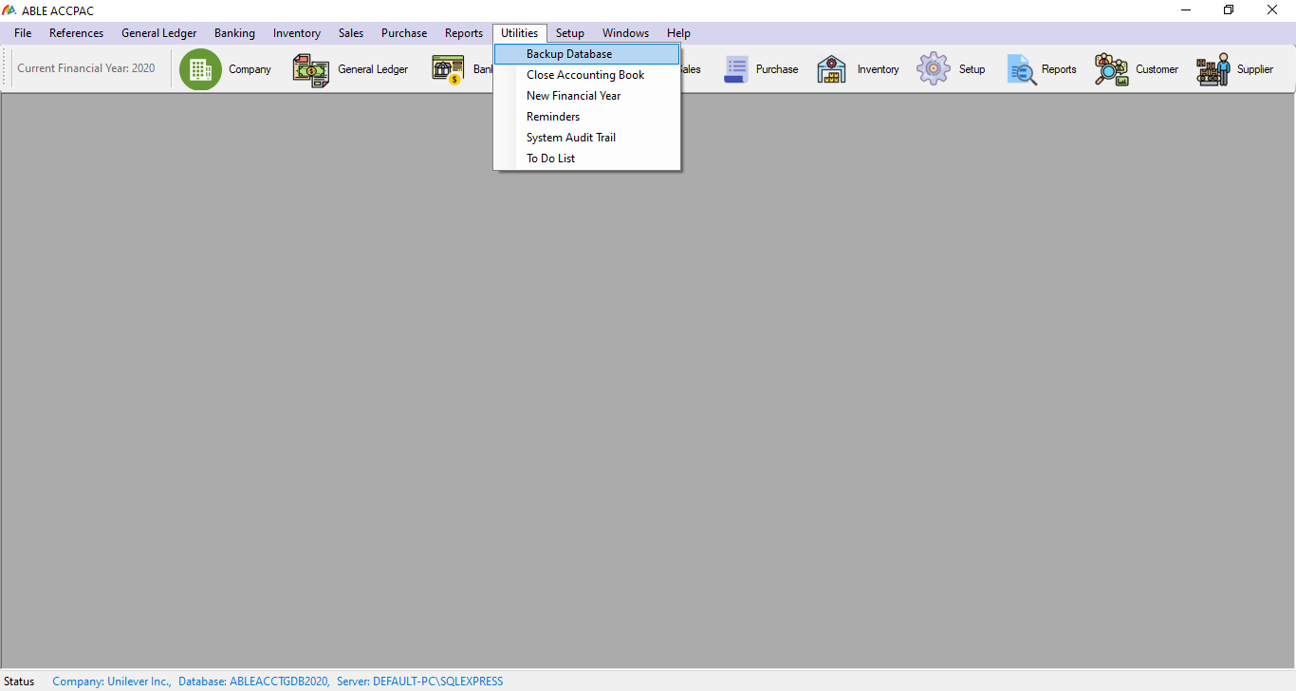

Then click the backup database to save your existing database

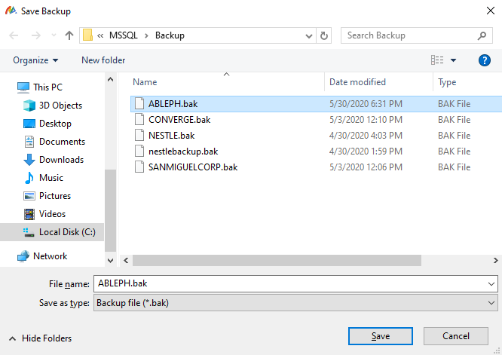

Click the save button.

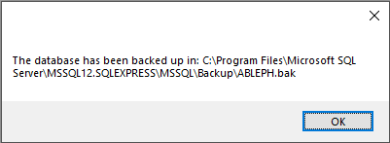

This will appear if the database file has been successfully save.

Note: You should specify that the folder you are saving is rooted in the SQL server folder under your program files directly to the backup folder where the SQL management tools backup function is allocating your database file or your .bak file. See example in the picture.

# SQL Restore DB

To Restore Existing DB and to use for future purposes.

1. First you should specify the server authentication and your server name in your SQL management tools.

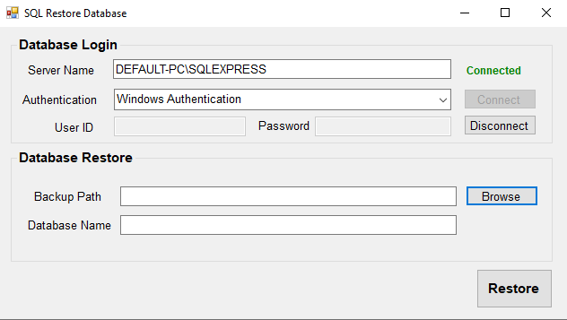

Then hit the connect button.

1. After connecting you browse the database file or the .bak file that has been save in the SQL server folder under your program files directly to the backup folder where the SQL management tools backup function is allocating your database file.

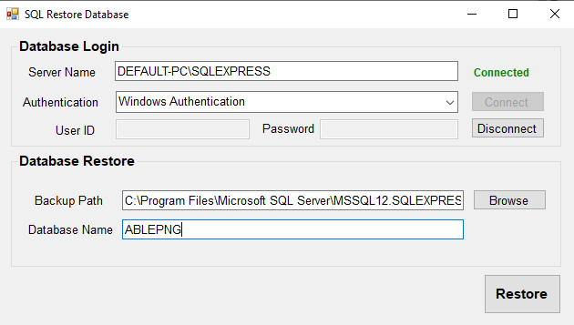

Then name your database to the company you want which you will create later on in the company profile editor. Then click the restore button

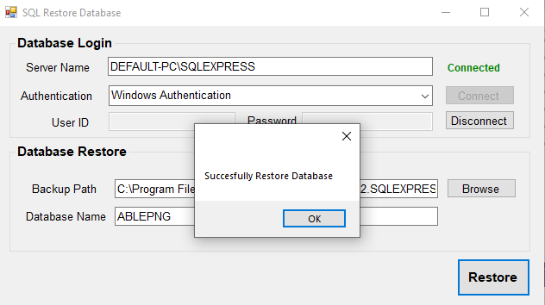

# Company Profile Editor

To Save And to Restore company file created by the user

1. Click Add New button to create new company file

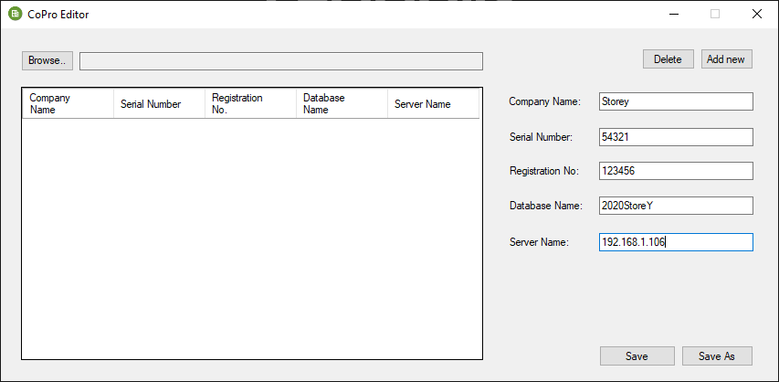

1. And then Click Save As to create the file for the company, which will prompt the user to name the file.

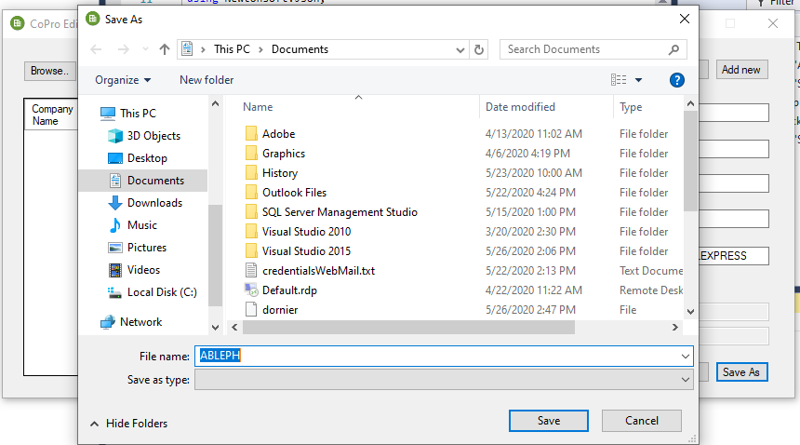

* + - Company file created successfully



1. Restoring Company File
   * + Click the Browser Button to select the Created company profile which was saved as a file in your computer.

